Current Target: <https://webscraper.io/test-sites>

Tools :OWASP ZAP

Wrote by Maryam

Vulnerability and solution

Attack tool OWASP ZAP

The content security policy header is not set

Risk: Medium

Missing anti-clickjacking header

Risk: Medium



Sub resource integrity attribute missing

risk: Medium

Cookie without same site attribute

risk: Low

Cross-domain JavaScript source file inclusion

Risk: low

Permission policy header not set

Risk:low

Timestamp disclosure Unix

Risk: low

CORS header

Risk: Informational



Non-storable content

Risk: Informational

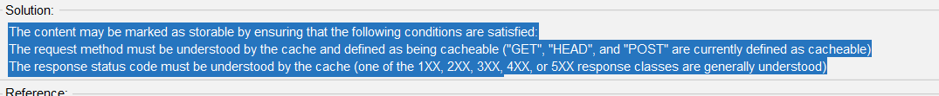

Strict-transport security header not set

risk:Low

Server leaks version information via server HTTP response header field

risk:Low



Cookie not HTTP only flag

risk:Low

Big redirect detected

risk:Low

Source Code disclosure -SQL

Risk:Medium



Source Code disclosure -PHP

Risk:Medium



Proxy Disclosure

Risk:Medium



